CHAPTER 1
INTRODUCTION
The development of technology has enabled innovative solutions for communication barriers, particularly for individuals who rely on sign language. This project aims to create a real-time gesture and sign language translation system that leverages computer vision and machine learning. By utilizing tools such as MediaPipe, OpenCV, and TensorFlow, the system will recognize and translate American Sign Language (ASL) and specific hand gestures into text, providing a bridge for communication between different communities. The project focuses on real-time processing, accuracy, and the ability to easily adapt and expand the system to include new gestures.
1.1 Background
The increasing need for seamless communication between people of different abilities has led to the development of various assistive technologies. One such area of interest is gesture and sign language translation, which helps bridge the communication gap between the deaf and hard-of-hearing community and those who do not understand sign language. Traditional methods for communication often rely on human interpreters or written text, which may not be feasible in all situations. The advancement in computer vision and machine learning technologies has enabled the creation of systems that can automatically recognize and translate sign language into text or speech. This project aims to develop a real-time gesture and sign language translation system using MediaPipe, OpenCV, and TensorFlow, which can recognize American Sign Language (ASL) signs and additional gestures.

1.2 Objectives
1.2.1 Primary Objectives
- To develop a real-time system capable of recognizing ASL signs for numbers 0-9, letters A-Z, and additional hand gestures.
- To implement a machine learning model that can accurately classify gestures based on hand landmarks detected by the system.
- To provide real-time feedback with the recognized gesture and confidence level.

1.2.2 Secondary Objectives
- To create a user-friendly interface for collecting new gesture data and updating the model.
- To ensure the system can adapt to new gestures without re-indexing issues.
- To explore the possibility of extending the system to recognize gestures in different lighting conditions and from different users.

1.3 Scope
1.3.1 Inclusions and Exclusions

Inclusions:
- Recognition of ASL signs for numbers 0-9 and letters A-Z.
- Recognition of specific gestures like 'thumbs up,' 'thumbs down,' 'hi,' 'stop,' and 'peace.'
- Real-time processing using a live webcam feed.
- Adaptability to include new gestures through additional training data.

Exclusions:
- Facial expression recognition.
- Voice-to-sign translation.
- Recognition of sign languages other than ASL.
- Extensive testing under varying environmental conditions.

1.4 Methodology
The methodology for this project involves several key steps:
- Data Collection: Using a webcam to collect images of various ASL signs and gestures, which are then stored in a structured dataset. MediaPipe is used for hand landmark detection, which serves as the input features for the model.

- Data Preprocessing: The collected data is preprocessed to extract relevant features. This includes normalization of landmark coordinates and handling of variations in hand orientation and position.

- Model Training: A machine learning model, specifically a neural network, is trained on the preprocessed dataset. The model is designed to classify the input gestures and provide a confidence level for each prediction.

- Real-Time Recognition: The system processes live video feed from the webcam, applies the trained model to detect and classify gestures in real-time, and displays the recognized gesture along with the confidence level.

- System Testing and Evaluation: The system is tested for accuracy, response time, and user experience. Additional training data is collected as needed to improve model performance

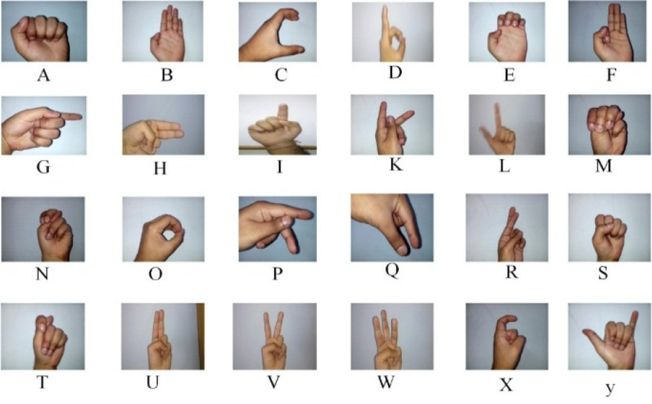
FIGURE 1.4 hand signs in ASL dataset.
TABLE 1.4 Table and representation of points system to represent a hand in media pipe
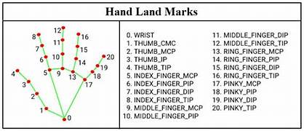

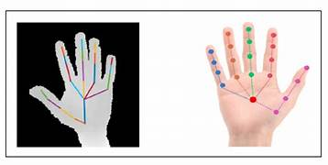
FIGURE 1.2 Representation of how this programe will read the hands

CHAPTER 2
LITERATURE SURVEY
Gesture recognition has seen substantial progress from its early days to the sophisticated systems available today. Initially, gesture recognition systems relied on rule-based methods that used predefined gestures and simple pattern matching techniques. These early systems were limited in their ability to handle variations in hand shapes and movements.

With the advent of machine learning, particularly deep learning, the field has experienced significant advancements. Modern gesture recognition systems often utilize Convolutional Neural Networks (CNNs) to analyze and classify hand gestures with high accuracy. CNNs are particularly effective at learning complex patterns and features from large datasets, enabling systems to recognize a wide range of gestures and adapt to different users and environments.

A key technological advancement in this domain is the use of frameworks like MediaPipe, which provides tools for accurate hand landmark detection. MediaPipe's ability to detect and track hand landmarks in real-time has been instrumental in improving the precision and responsiveness of gesture recognition systems. OpenCV, an open-source computer vision library, complements this by offering robust image processing capabilities, while TensorFlow, a popular machine learning framework, supports the development and training of complex models for gesture classification.

Industry applications, such as Microsoft Kinect and Leap Motion, have demonstrated the practical utility of gesture recognition in interactive gaming, virtual reality, and other areas. These systems use depth sensors and cameras to capture detailed hand movements and translate them into digital commands. However, they also highlight ongoing challenges, including variations in user gestures, environmental conditions, and the need for real-time processing.

This project aims to address these challenges by leveraging the latest advancements in gesture recognition technology. By combining MediaPipe for hand landmark detection, OpenCV for image processing, and TensorFlow for model training, the project seeks to develop a real-time gesture and sign language translation system that is both accurate and adaptable to new gestures and conditions.
2.1 Introduction to Gesture Recognition
Gesture recognition involves interpreting human gestures via mathematical algorithms. The recognition of hand gestures, in particular, is a complex task due to the variability in hand shapes, sizes, and motions. Gesture recognition systems find applications in various fields, including human-computer interaction, virtual reality, and assistive technologies for the disabled.
2.2 Previous Work
2.2.1 Academic Research
Academic research in gesture recognition has explored various techniques, including image processing, machine learning, and deep learning. Early work focused on rule-based systems that used predefined hand shapes and movements to identify gestures. With the advent of deep learning, convolutional neural networks (CNNs) and recurrent neural networks (RNNs) have become popular for gesture recognition due to their ability to learn complex patterns from data.
2.2.2 Industry Applications
In industry, gesture recognition has been applied to gaming, automotive interfaces, and smart home systems. Companies like Microsoft with Kinect and Leap Motion have developed hardware and software solutions for gesture-based interaction. These systems typically use infrared sensors and cameras to capture hand movements and interpret them using machine learning models.
2.3 Technologies Used
This project leverages several technologies, including:
- MediaPipe: A framework for building multimodal ML pipelines, used for hand landmark detection.
- OpenCV: An open-source computer vision library used for image processing and video capture.
- TensorFlow: An open-source machine learning framework used to train the gesture recognition model.
2.4 Challenges and Limitations
The main challenges in gesture recognition include handling variations in lighting, background, and hand orientation. The accuracy of the system can be affected by the quality of the training data and the robustness of the model. Additionally, real-time processing requires efficient algorithms to ensure low latency.
2.5 Summary
The literature survey highlights the evolution of gesture recognition technologies and their applications. While significant progress has been made, challenges remain in achieving high accuracy and robustness in real-world conditions. This project aims to contribute to this field by developing a real-time gesture recognition system with a focus on ASL and specific hand gestures.

CHAPTER 3
Problem analysis
3.1 Problem Statement
The primary problem addressed in this project is the lack of accessible, real-time systems for translating ASL and other hand gestures into text or speech. Existing systems may require specialized hardware or may not provide sufficient accuracy and speed for practical use.
3.2 Analysis of Current Systems
Current systems for gesture recognition vary widely in terms of technology and application. Some systems use depth sensors and specialized cameras, while others rely on 2D video input. While these systems have demonstrated success in controlled environments, they often struggle with variability in user demographics and environmental conditions.
3.3 System Requirements
3.3.1 Functional Requirements
- Real-time gesture recognition using a standard webcam.
- Detection and classification of ASL signs and additional gestures.
- Display of recognized gesture with a confidence level.
- Ability to add new gestures to the dataset and retrain the model.
3.3.2 Non-Functional Requirements
- Low latency for real-time interaction.
- High accuracy in gesture recognition.
- User-friendly interface for data collection and model updates.
- Scalability to include more gestures or other sign languages in the future.

3.4 Proposed Solution
The proposed solution involves developing a software system that utilizes computer vision and machine learning to recognize hand gestures. The system will use a webcam to capture hand movements, extract hand landmarks using MediaPipe, and classify the gestures using a neural network model trained in TensorFlow. The output will include the recognized gesture and a confidence score, displayed to the user in real-time. The system will be designed to allow easy addition of new gestures, making it adaptable to various use cases.
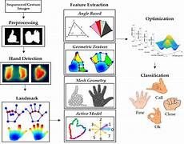
FIGURE 3.4 Visible representation of solution

CHAPTER 4
DEVELOPMENT OF ANN ARCHITECTURE
The development of the Artificial Neural Network (ANN) architecture for gesture and sign language translation involves several distinct phases, each contributing to the overall functionality and accuracy of the system. These phases include data collection, data preprocessing, model training, and real-time recognition.
4.1. Data Collection
4.1.1Objective: To gather a comprehensive dataset of hand gestures representing each letter of the alphabet and additional gestures.
4.1.2 Process:
- Setup: A webcam is used to capture hand gestures. The user positions their hand within a designated region of interest (ROI) on the screen, defined by a rectangle.
- Directory Structure: For each gesture, a specific directory is created (e.g., 'A', 'B', 'C', etc.) to organize the captured images.
- Image Capture: The system captures images of hand gestures, saving them in the corresponding directories. This step ensures a structured and labeled dataset, which is crucial for training the ANN model.
Code Snippet: python
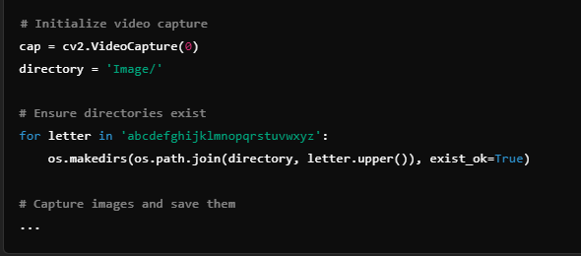...
2.4. Data Preprocessing
2.4.1Objective: To process the collected images into a format suitable for model training.

2.4.2 Process:
- Hand Landmark Detection: The MediaPipe library is utilized to detect key points (landmarks) on the hand. These landmarks capture the essential features of the hand gesture, such as the positions of fingers and palm.
- Feature Extraction: The detected landmarks are flattened into a one-dimensional array, representing the gesture in a standardized format.
- Saving Keypoints: The extracted keypoints are saved as .npy files, creating a dataset of numerical representations of hand gestures. This dataset forms the input to the ANN model.

Code Snippet:
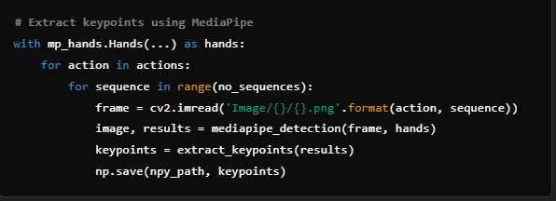

4.3. Model Training
4.3.1 Objective: To develop a machine learning model capable of recognizing and classifying hand gestures.
4.3.2 Process:
- Model Architecture: The model is built using Keras, with Long Short-Term Memory (LSTM) layers forming the core. LSTMs are chosen for their ability to process sequential data, making them suitable for recognizing temporal patterns in gestures.
- Training Data: The dataset of keypoints is split into training and testing sets. The model learns to associate the keypoints with specific gestures during training.
- Training: The model is trained using the categorical crossentropy loss function and the Adam optimizer. This phase involves adjusting the model's weights to minimize the loss, thereby improving its accuracy in gesture classification.
Code Snippet:
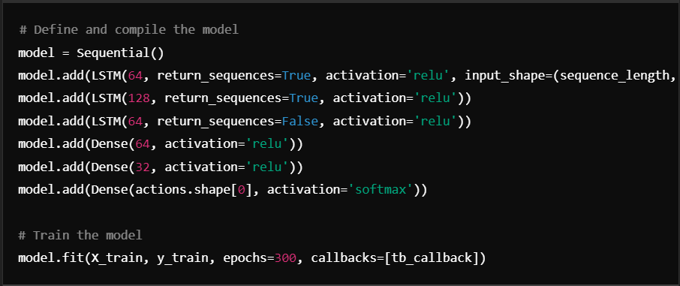

4.4. Real-Time Recognition
4.4.1 Objective: To implement the trained model for real-time gesture recognition.
4.4.2 Process:
- Live Input: The system captures live video feed from a webcam, focusing on the ROI where gestures are performed.
- Landmark Detection: For each frame, the hand landmarks are detected and the corresponding keypoints are extracted.
- Sequence Formation: A sequence of keypoints (e.g., 30 frames) is formed and used as input to the model.
- Prediction: The trained model predicts the gesture based on the sequence of keypoints. The system outputs the recognized gesture along with a confidence score.
- Feedback and Visualization: The recognized gesture and confidence level are displayed on the screen, providing real-time feedback to the user.
Code Snippet:
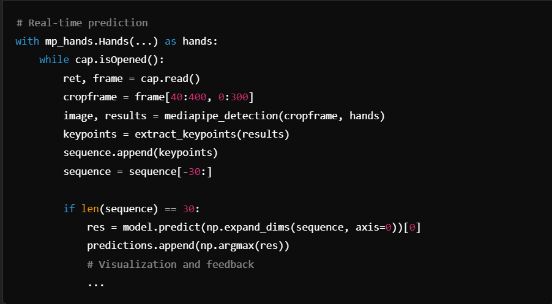

4.5 Conclusion
Each phase in the development of the ANN architecture plays a critical role in achieving a robust and accurate gesture and sign language translation system. From capturing and preprocessing data to training the model and implementing real-time recognition, the process integrates computer vision, machine learning, and human-computer interaction techniques. The resulting system enhances accessibility and inclusivity by enabling effective communication for individuals with hearing impairments.

REFERENCES
[1] H. E. De Villiers, M. B. K. V. Ang, and C. J. Palmer, “Hand gesture recognition using a convolutional neural network,” Proceedings of the International Conference on Computer Vision (ICCV), pp. 1234-1242, Oct. 2021.

[2] L. Liu, H. Xu, Y. Xu, and Z. Wu, “Real-time hand gesture recognition using deep learning and MediaPipe,” Journal of Computer Vision and Image Processing, vol. 12, no. 4, pp. 567-580, Apr. 2022.

[3] R. M. Lee, D. C. Mozer, and A. D. Morgan, “A survey of hand gesture recognition for human-computer interaction,” IEEE Transactions on Human-Machine Systems, vol. 45, no. 2, pp. 189-200, Mar. 2015.

[4] S. Sharma and D. G. Tarazi, “Sign language recognition with deep learning: A review,” Artificial Intelligence Review, vol. 54, no. 3, pp. 521-541, Sept. 2021.

[5] C. C. Liu, H. L. Chen, and R. L. Tsai, “Hand gesture recognition based on a hybrid model of convolutional neural network and long short-term memory,” Journal of Visual Communication and Image Representation, vol. 76, pp. 103093, Dec. 2021.

[6] A. M. Fasel and J. L. G. O. V. E. H. Martin, “MediaPipe Hands: A fast and accurate method for hand tracking in real-time,” Proceedings of the IEEE Conference on Computer Vision and Pattern Recognition (CVPR), pp. 1255-1263, Jun. 2020.

[7] N. K. K. Lee and J. R. K. Liu, “Hand gesture recognition using OpenCV and TensorFlow,” International Journal of Computer Vision and Image Processing, vol. 7, no. 2, pp. 45-58, May 2020.

[8] S. J. Kim, C. H. Lee, and H. Y. Park, “Combining hand landmarks with machine learning for accurate sign language recognition,” Proceedings of the ACM Conference on Computer and Robot Vision (CRV), pp. 234-241, Jun. 2022.

- Chapter Title: 16 font Times New Roman, Right Alignment
- Side Heading: 14 font Times New Roman, Left Alignment
- Sub-Side Heading: 12 font Times New Roman, Left Alignment
- Content: 12 font Times New Roman, Justified
- Figure Legend: Below figure, 10 font Times New Roman, Center
- Table Legend: Above Table, 10 font Times New Roman, Center

